Impact Test:
- An impact test signifies toughness of the material, which is ability of material to absorb energy during plastic deformation. Static tension test of un notched specimen do not always reveal the susceptibility of a metal to brittle fracture. This important factor is determined by impact test. Toughness takes into account both the strength and ductility of the material.
- As the several engineering materials have to withstand impact or suddenly applied load while in service and since impact strength are generally lower as compared to the strength achieved under gradually applied load therefore it is necessary to establish a comparison between toughness of different material or toughness of the same material under different condition.
- Impact Test: A pendulum type impact testing machine is generally used for conducting notched bar impact test. There are two types of impact test which can be performed on this machine:
- Izod Test 2. Charpy Test

- Izod Test: This test uses a cantilever test piece of 10 mm x 10 mm section specimen having standard 45º notch 2 mm deep. This is broken by means of a swinging pendulum which is allowed to fall from a certain height to cause an impact load on the specimen. The angle rise of pendulum after rupture of the specimen or the energy to rupture the specimen is indicated by graduated scale of a pointer.
The energy required to rupture the specimen is the function of the angle of rise.

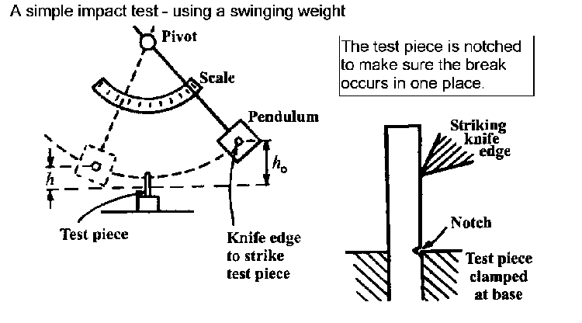

- Charpy Test: This test uses a simply supported test piece of 10 mm x 10 mm section specimen having standard 45º notch 2 mm deep. The specimen is placed on supports or anvil so that blow of striker is opposite to the notch.

The energy used in rupturing the specimen in both the test is calculated as follows:
Initial Energy = WH = W (R - R$\cos{α}$) = WR (1- $\cos{α}$)
Energy after rupture = W$H^{'}$ = W (R - R$\cos{β}$) = WR (1- $\cos{β}$)
Energy used to rupture = WH - W$H^{'}$ = WR ($\cos{β}$ - $\cos{α}$)
Where, W = Weight of the pendulum
H = Height of fall of centre of gravity of the pendulum/striker
$H^{'}$ = Height of rise of centre of gravity of the pendulum/strike
$α$ = Angle of fall
$β$ = Angle of rise
R = Distance from C.G of pendulum to axis of rotation
- Effect of important variables on impact strength:
- Angle of Notch: No appreciable effect until its value exceeds 60º
- Shape of the Notch: Sharpness of the notch increases the energy required to rupture.
- Dimension of the specimen: by decreasing the dimension of the specimen the energy of rupture decreases.
- Velocity of impacts: The impact resistance of decreases above certain critical velocity, this varies from metal to metal.
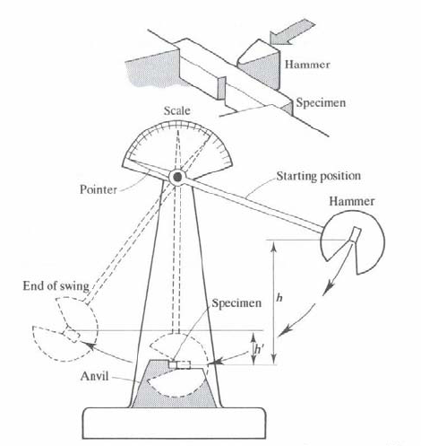

Hardness Testing:
The hardness of a material is its resistance to penetration under a localized pressure or resistance to abrasion. The hardness test can be determined by any one of the following test:
- Indentation or penetration test
- Brinell
- Vicker’s
- Rockwell.
- Rebound test
- Scratch test
- Brinell hardness test: In this test, a standard hardened steel ball is pressed into the surface of the specimen by a gradually applied load which is maintained on the specimen for a definite time. The impression so obtained is measured by a microscope and the Brinell Hardness Number (B.H.N.) is found by the following expression:
B.H.N. = $\frac{Load}{Area of impression/ indentation}$ = $\frac{2P}{π D (D-\sqrt{D^{2}}-d^{2 })}$
Where, P = Load (kg),
D = Diameter of ball (mm) and
d = Diameter of indentation (mm)
- Vicker’s hardness test: In this test, a polished square based pyramid diamond tool with an angle of 136º is pressed into the surface of the specimen by a gradually applied load in order to make an impression on the specimen. The load when divided by the area of indentation in mm² gives what is known as pyramid hardness number (D.P.N.):

D.P.N. = $\frac{2P \sin{θ/2}}{d^{2}}$
Where, P = Load (kg),
$θ$ = angle between the opposite faces, and
d = mean length of the two diagonals in mm
The Vicker’s test is more précised as well as it can be used for harder material as compared to the Brinell test,

- Rockwell hardness test: The Rockwell hardness test is probably the most widely used method of hardness testing. In this test four sizes of hard ball from 1/6 inch to ½ inch in diameter and a cone shape diamond are used as penetrator. The specimen is placed on the anvil of the machine and the penetrator seated by means of a minor load of 10 kg. The dial indicator is zeroed and then a major load of 60/100/150 and etc is applied, forcing the penetrator into the specimen. And in this way upon removal of major load the final depth of penetration is registered directly on the dial indicator as a hardness number.
The two commonest scales are the HRB scale (1/16 inch ball with 100 kg load) and the HRC scale (the diamond penetrator with 150 kg major load).
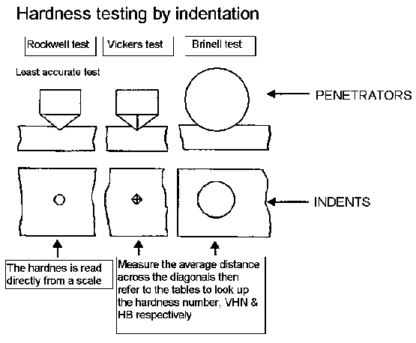
- Rebound Test: In this test a steel cylinder hammer is dropped from a height of 25cm. through a glass tube on the surface to be tested. The height of rebound is used as a measure of hardness of surface.

- Scratch Test: In this test a scratch of 0.01 mm wide is made on the material to be tested by forcing a 90º diamond with a load. This load in grams under which 90º diamond will produce a scratch of 0.01 mm wide is known as scratch hardness of that material.

Fatigue Test:
- Fatigue failure occurs as a result of repeated application of small loads which are individually incapable of producing detectable plastic deformation. Eventually these repeated loads cause a macro-crack to open and spread across the piece. And hence stress intensification occurs and ultimately sudden, brittle fracture results. (Fracture caused by fatigue is of brittle nature, even in ductile material).
- The basic mechanism of Fatigue is “Slip”. Fatigue is a result of cumulative process of involving slip.
- Fatigue failure starts at the point of highest stress.
- Fatigue failure takes place due the following reasons:
- Poor surface finish, such as tool mark or scratches.
- Internal void such as shrinkage cracks and cooling cracks in castings and weldments.
- Stress concentration points like notches, keyways, screw threads and machining undercuts.
- Defects, stresses induced by electroplating.

- Fatigue Test: There are various machines available to carry out the fatigue test for long periods under varying load and at high frequency. A rotary bending test based “Wholer System” is one of those machine in which a rotating shaft is subjected to a steady bending moment. When the shaft rotates the test piece which is mounted on the shaft passes through tension and compression alternately.
After performing the fatigue test its result is drawn as fatigue curve or the S/N (maximum stress/ No. of cycles to failure) curve. It shows the magnitude of stress causing failure as a function of no. of cycles.
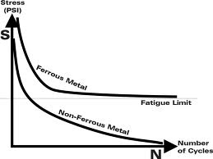
- Procedures to avoid Fatigue failure:
- Precise control of the surface finish
- Modification of the design to avoid stress concentration
- Surface treatment of metal
- Control of corrosion and erosion or chemical attack in service and prevention of surface decarburization during processing or heat treatment.

- Fatigue or Endurance Limit: It is maximum value of repeated stress which can be applied and reversed for an indefinitely large number of cycles without causing failure or fracture of the material.
If a material is loaded below the fatigue limit, it will not fail, no matter, how many times the stress is applied.
For steel fatigue limit varies from 15 to 80 x 10⁷ N/mm² (0.4 to 0.5 of ultimate tensile strength)
- Fatigue Strength: It is the stress that will cause fracture after certain specified number of cycles say 10⁶, 10⁷, or 10^{8.}
Creep Test:
- Creep is a slow plastic deformation of metals under constant stresses or under prolonged loading usually at high temperature. It can take place and lead to fracture at static stresses smaller than those which will break the specimen by loading it quickly.
- Creep is specially taken care of while designing I.C. engines, boilers, and turbines.
- Creep at room temp……. low temp creep……..occur in load pipes, roofing’s, glass
- Creep at high temperature………….High temp creep
- Creep Test: The specimen to be tested is placed in the electric furnace where it is heated to a given temperature and constantly subjected to a load. The strain variations are measured with strain gauges. The plot with time will be as shown in figure below. The various stages are explain as follows:
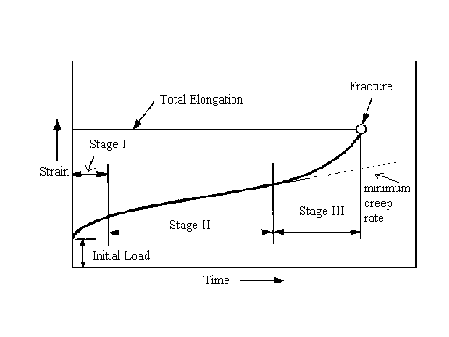
- Primary stage: primary creep represents a transient stage in which the resistance of the metal increases to its own deformation.
- Secondary stage: this stage of the curve indicates the period of extension during which the creep occurs more or less at constant rate. Secondary creep is the result of balance between process of strain hardening and recovery.
- Tertiary stage: In this stage the rate of extension or strain rate accelerates, rapidly leading to fracture finally. Tertiary creep is considered to be due to necking.
- Factors affecting creep:
- Load: Creep strain rate varies directly with the applied load. With a higher applied stress creep strain rate increases.
- Temperature: Higher temperature increases the creep rate i.e. material creeps more in the same period of loading at higher temperature as compared to lower one.
- Composition: Pure metals has high creep rate.
- Grain Size: At lower temperature a material with a smaller grain size has a slower creep rate. Coarse grains show higher creep rate. But at higher temperature, the behavior is reversed.

- Creep Resisting Materials:
- Low alloys ferritic steels ( good up to 600ºC)
- High alloy ferritic steels ( good up to 950ºC)
- Nickel based super alloys ( good up to 950ºC)
- Refractory oxides and carbides (good up to 1300ºC).

NON-DESTRUCTIVE TESTS
It may be defined as those tests in which in a specific context would not damage the material being examined to an extent such that it is rendered useless for future for which it was originally meant.
The various methods used for non-destructive testing are as follows:
- X-RAY radiography.
- Gamma radiography.
- Magnetic particle inspection.
- Ultrasonic testing.
- Electrical method .
- Damping test.

- X- ray radiography
Radiography technique is based upon exposing the components to short wavelength radiation in the form of x-rays having wavelength less than 0.001*10^ (-8) cm to about 40*10^ (-8) or gamma rays from suitable source such as X-ray tube or cobalt -60.
These tests are used to detect defect such as blow holes, racks shrinkage cavities and slag inclusions.
In X-ray radiography, the portion of the casting where defects are suspecte , is exposed to x-ray emitted from the X-ray tube .a cassette containing X-ray film placed behind and in contact with the casting perpendicular to the rays .
In the exposure of the X-ray, the defect having lesser density than sound metal, transmit X-ray better than the sound metal does.
Thus, film appears to be darker where defects are in line of X-ray beam. The exposed and developed x-ray film showing light and dark area is termed as RADIOGRAPH.

- GAMMA RADIOGRAPHY
The principle of detecting defect is same as X-ray radiography. Gamma rays are emitted during disintegration of the radio-active material and like X-rays are electromagnetic radiations. Gamma rays are shorter in wavelength and consequently are more penetrating.

ADVANTAGES
- Unlike X-ray, gamma-rays from its source are emitted in all direction, therefore ,a number of separate casting having cassette containing film, fastened back of each casting, are disposed in a circle around the space placed in a central position.
- Gamma rays are used for detecting defect in casting thicker than those inspected by X-ray.
- Less costly apparatus used.
3 MAGNETIC PARTICLE INSPECTION
This test is generally used to locate cracks and surface defect in a wide range of product.
This method involves mainly two steps.
- Magnetization of material ,and
- Application of finely divided magnetic particles.
The defects such as blow holes , cracks and inclusion In magnetic particle produce a distortion in an induced magnetic field which are also known as leakage flux .
A liquid solution containing very tiny magnetic particles is sprayed on the surface being checked and sample is then subjected to a strong magnetic field. The leakage flux act as free pole, attract the tiny magnetic particle present in solution. After the removal of the magnetic field, particles get concentrated at the sites where defect presents.
The specimen should be magnetized with the direction or magnetic field perpendicular to the defect for the maximum sensitivity.

- ULTRASONIC TESTING
The sound wave whose frequency is above the upper pitch limit of the human ear are called ultrasonic.
Ultrasonic waves are usually generated by the piezoelectric effect which converts electrical energy to mechanical energy using a quarter crystals.
When the ultrasonic waves passes from one medium to other, some reflection takes place . any defect such as internal crack , porosity or non- metallic inclusion , will therefore act as a reflecting surface for ultrasonic waves. Ultrasonic waves are produced by stimulating piezoelectric crystal into high frequency vibration by an electrical signal.
The crystal is highly damped and only short duration pulse is generated.
A small defect returns a small echo, which appears as a short vertical peak on CRO screen whereas a large vertical defect will appear as a large peak.
- ELECRICAL METHOD
Electrical method consist in measuring the electrical resistance of the material and then to note the variation in the electrical resistance. The variation is correlated to physical defect.
A crack detector operates on the principle that if the crack occurs within the piece it interferes with the flow of current through the metal, therefore , increasing its overall resistance.
This holds true regardless shape of the piece.

- DAMPING TEST
Measurement of damping can give information on the origin of defect such as forming of quenching cracks.
For example, an increase in damping was found in steel specimen which had been quenched.

