DNA STRUCTURE

DNA is that it is usually composed of two polynucleotide chains twisted around each other in the form of a double helix. The backbone of each strand of the helix is composed of alternating sugar and phosphate residues which are present projecting on the out side of the double helix forming hydrophilic interactions with the water molecules. The nitrogenous bases of both strands are stacked inside the double helix with their hydrophobic and planar ring structures perpendicular to the long axis of the DNA. These bases on the two strands of DNA undergo specific base pairing that creates a major groove and minor groove on the surface of the duplex.

Each nucleotide is made up of 3 components a nitrogenous base, a deoxyribose sugar and a phosphate group.
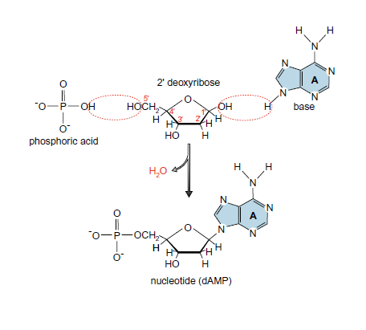
Formation of Nucleotide by Removal of Water. The numbers of the carbon atoms in 2’ deoxyribose are labeled in red.

The bases in DNA fall into two classes, purines and pyrimidines. The purines are adenine and guanine, and the pyrimidines are cytosine and thymine. The purines are derived from the double-ringed structure while pyrimidines are derived from single ring structures. Watson and Crick found that the hydrogen-bonding is present in between the bases - three hydrogen bonds can form between G and C, but only two can form between A and T.

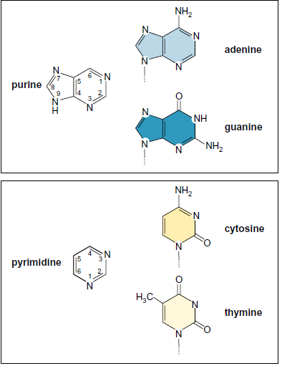
Purines and Pyrimidines

The two strands of the DNA double helix are in antiparallel orientation, which means that of the two strands of DNA one strand runs in 3' to 5' direction and the other runs from 5' to 3' direction.

The Two Chains of the Double Helix Have Complementary Sequences.
The pairing between adenine and thymine and between guanine and cytosine results in a complementary relationship between the sequence of bases on the two polynucleotide chains. For example, if we have the sequence 5'-ATGTC-3' on one chain, the opposite chain must have the complementary sequence 3'-TACAG-5'.

Dimensions of DNA
The one complete 360 ˚ twist in the DNA double helix is 34 Å in length. and the vertically stacked bases inside the double helix would be 3.4 Å apart; thus accounting for by the presence of 10 base pairs in each complete turn (of 360 ˚) of the double helix.

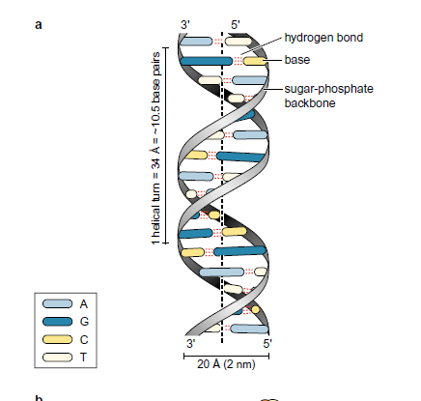
Structure of DNA double helix

