A perfect crystal, with every atom of the same type in the correct position, does not exist. All crystals have some defects. Here are basic classes of crystal defects:
- Point defects, which are places where an atom is missing or irregularly placed in the lattice structure. Point defects include lattice vacancies, self-interstitial atoms, substitution impurity atoms, and interstitial impurity atoms
- Linear defects, which are groups of atoms in irregular positions. Linear defects are commonly called dislocations.
- Planar defects, which are interfaces between homogeneous regions of the material. Planar defects include grain boundaries, stacking faults and external surfaces.
NOTE: It is important to note at this point that plastic deformation in a material occurs due to the movement of dislocations (linear defects). Millions of dislocations result for plastic forming operations such as rolling and extruding. It is also important to note that any defect in the regular lattice structure disrupts the motion of dislocation, which makes slip or plastic deformation more difficult. These defects not only include the point and planer defects mentioned above, and also other dislocations. Dislocation movement produces additional dislocations, and when dislocations run into each other it often impedes movement of the dislocations. This drives up the force needed to move the dislocation or, in other words, strengthens the material. Each of the crystal defects will be discussed in more detail in the following pages.
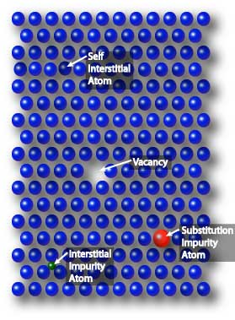
Point Defects
Point defects are where an atom is missing or is in an irregular place in the lattice structure. Point defects include self interstitial atoms, interstitial impurity atoms, substitutional atoms and vacancies.
A self interstitial atom is an extra atom that has crowded its way into an interstitial void in the crystal structure. Self interstitial atoms occur only in low concentrations in metals because they distort and highly stress the tightly packed lattice structure.
A substitutional impurity atom is an atom of a different type than the host atoms, which has replaced one of the host atoms in the lattice. Substitutional impurity atoms are usually close in size (within approximately 15%) to the host atom. An example of substitutional impurity atoms is the zinc atoms in brass. In brass, zinc atoms with a radius of 0.133 nm have replaced some of the copper atoms, which have a radius of 0.128 nm.
Interstitial impurity atoms are much smaller than the atoms in the bulk matrix. Interstitial impurity atoms fit into the open space between the bulk atoms of the lattice structure. An example of interstitial impurity atoms is the carbon atoms that are added to iron to make steel. Carbon atoms, with a radius of 0.071 nm, fit nicely in the open spaces between the larger (0.124 nm) iron atoms.
Vacancies are empty spaces where an atom should be, but is missing. They are common, especially at high temperatures when atoms are frequently and randomly change their positions leaving behind empty lattice sites. In most cases diffusion (mass transport by atomic motion) can only occur because of vacancies.
Imperfections in Ceramics
Imperfections in ceramic crystals include point defects and impurities like in metals. However, in ceramics defect formation is strongly affected by the condition of charge neutrality because the creation of areas of unbalanced charges requires an expenditure of a large amount of energy. In ionic crystals, charge neutrality often results in defects that come as pairs of ions with opposite charge or several nearby point defects in which the sum of all charges is zero. Charge neutral defects include the Frenkel and Schottky defects.
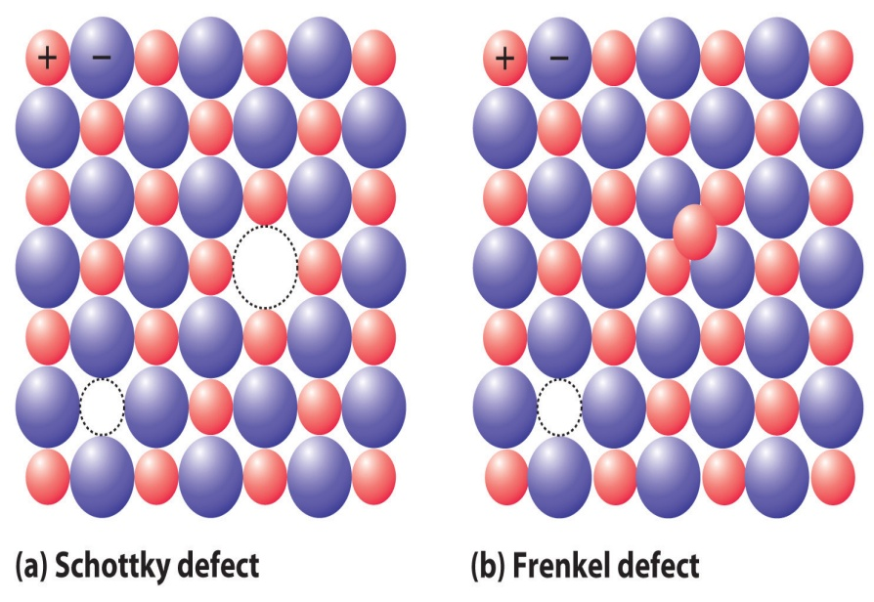
A Frenkel-defect occurs when a host atom moves into a nearby interstitial position to create a vacancy-interstitial pair of cations i.e. this defect involves cation-vacancy & cation-interstitial pair.
A Schottky-defect is a pair of nearby cation and anion vacancies. Schottky defect occurs when a host atom leaves its position and moves to the surface creating a vacancy-vacancy pair i.e. this defect involve cation-vacancy & anion-vacancy pair.

Linear Defects – Dislocations
Dislocations are another type of defect in crystals. Dislocations are areas were the atoms are out of position in the crystal structure. Dislocations are generated and move when a stress is applied. The motion of dislocations allows slip – plastic deformation to occur.
There are two basic types of dislocations, the edge dislocation and the screw dislocation. Actually, edge and screw dislocations are just extreme forms of the possible dislocation structures that can occur. Most dislocations are probably a hybrid of the edge and screw forms and these are termed as mixed dislocation.
Edge Dislocations
The edge defect can be easily visualized as an extra half-plane of atoms in a lattice. The dislocation is called a line defect because the locus of defective points produced in the lattice by the dislocation lie along a line. This line runs along the top of the extra half-plane. The inter-atomic bonds are significantly distorted only in the immediate vicinity of the dislocation line.
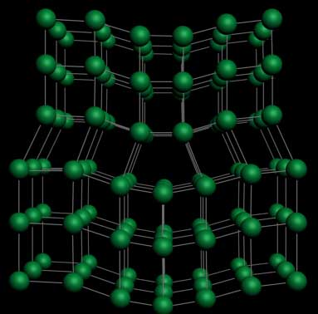
Understanding the movement of a dislocation is key to understanding why dislocations allow deformation to occur at much lower stress than in a perfect crystal. Dislocation motion is analogous to movement of a caterpillar. The caterpillar would have to exert a large force to move its entire body at once. Instead it moves the rear portion of its body forward a small amount and creates a hump. The hump then moves forward and eventual moves all of the body forward by a small amount.
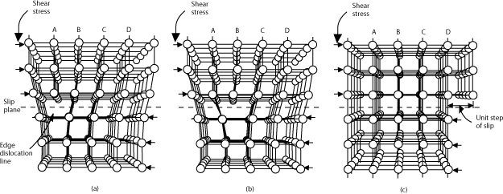
As shown in the set of images above, the dislocation moves similarly moves a small amount at a time. The dislocation in the top half of the crystal is slipping one plane at a time as it moves to the right from its position in image (a) to its position in image (b) and finally image (c). In the process of slipping one plane at a time the dislocation propagates across the crystal. The movement of the dislocation across the plane eventually causes the top half of the crystal to move with respect to the bottom half. However, only a small fraction of the bonds are broken at any given time. Movement in this manner requires a much smaller force than breaking all the bonds across the middle plane simultaneously.
Screw Dislocations
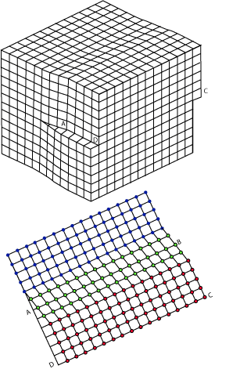
There is a second basic type of dislocation, called screw dislocation. The screw dislocation is slightly more difficult to visualize. The motion of a screw dislocation is also a result of shear stress, but the defect line movement is perpendicular to direction of the stress and the atom displacement, rather than parallel. To visualize a screw dislocation, imagine a block of metal with a shear stress applied across one end so that the metal begins to rip. This is shown in the upper right image. The lower right image shows the plane of atoms just above the rip. The atoms represented by the blue circles have not yet moved from their original position. The atoms represented by the red circles have moved to their new position in the lattice and have reestablished metallic bonds. The atoms represented by the green circles are in the process of moving. It can be seen that only a portion of the bonds are broke at any given time. As was the case with the edge dislocation, movement in this manner requires a much smaller force than breaking all the bonds across the middle plane simultaneously.
If the shear force is increased, the atoms will continue to slip to the right. A row of the green atoms will find their way back into a proper spot in the lattice (and become red) and a row of the blue atoms will slip out of position (and become green). In this way, the screw dislocation will move upward in the image, which is perpendicular to direction of the stress. Recall that the edge dislocation moves parallel to the direction of stress. As shown in the image below, the net plastic deformation of both edge and screw dislocations are the same, however.
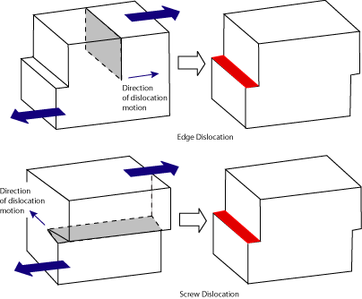
The dislocations move along the densest planes of atoms in a material, because the stress needed to move the dislocation increases with the spacing between the planes. FCC and BCC metals have many dense planes, so dislocations move relatively easy and these materials have high ductility.
Metals are strengthened by making it more difficult for dislocations to move. This may involve the introduction of obstacles, such as interstitial atoms or grain boundaries, to “pin” the dislocations. Also, as a material plastically deforms, more dislocations are produced and they will get into each other’s way and impede movement. This is why strain or work hardening occurs.

