Carbohydrates
Carbohydrates are polyhydroxy aldehydes or ketones, or substances that yield such compounds on hydrolysis. Many, but not all, carbohydrates have the empirical formula (CH2O)n; some also contain nitrogen, phosphorus, or sulfur.

There are three major size classes of carbohydrates: monosaccharides, oligosaccharides, and polysaccharides
Monosaccharides, or simple sugars, consist of a single polyhydroxy aldehyde or ketone unit. The most abundant monosaccharide in nature is the six-carbon sugar D-glucose. Monosaccharides of more than four carbons tend to have cyclic structures. Monosaccharides are reducing sugars.

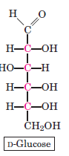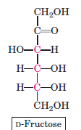

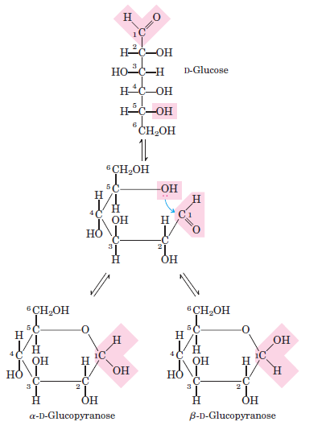
Formation of the two cyclic forms of D-glucose. Reaction
between the aldehyde group at C-1 and the hydroxyl group at
C-5 forms a hemiacetal linkage, producing either of two stereoisomers,
the α and β anomers, which differ only in the stereochemistry
around the hemiacetal carbon. The interconversion of α and β anomers
is called mutarotation.

Oligosaccharides consist of short chains of monosaccharide units, or residues, joined by characteristic
linkages called glycosidic bonds. The most abundant are the disaccharides, with two monosaccharide units.
Typical is sucrose (cane sugar), which consists of the six-carbon sugars D-glucose and D-fructose. All common
monosaccharides and disaccharides have names ending with the suffix “-ose.” In cells, most oligosaccharides
consisting of three or more units do not occur as free entities but are joined to nonsugar molecules (lipids or
proteins) in glycoconjugates.

Disaccharides (such as maltose, lactose, and sucrose) consist of two monosaccharides joined covalently by an
O-glycosidic bond, which is formed when a hydroxyl group of one sugar reacts with the anomeric carbon of
the other. Glycosidic bonds are readily hydrolyzed by acid but resist cleavage by base. Thus disaccharides can be hydrolyzed to yield their free monosaccharide components by boiling with dilute acid.

The disaccharide maltose contains two D-glucose residues joined by a glycosidic linkage between
C-1 (the anomeric carbon) of one glucose residue and C-4 of the other. Because the disaccharide retains
a free anomeric carbon, maltose is a reducing sugar. The configuration of the anomeric carbon atom in the glycosidic linkage is α.

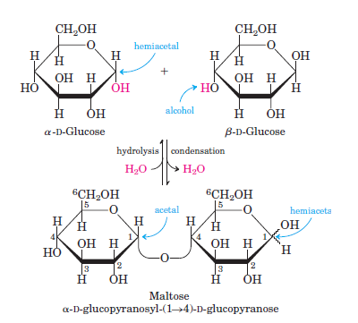
Formation of maltose. A disaccharide is formed from two monosaccharides (here, two molecules of D-glucose) when an
OOH (alcohol) of one glucose molecule (right) condenses with the intramolecular hemiacetal of the other glucose molecule (left), with elimination of H2O and formation of an O-glycosidic bond. The reversal of this reaction is hydrolysis—attack by H2O on the glycosidic bond. The maltose molecule retains a reducing hemiacetal at the C-1 not involved in the glycosidic bond.

The polysaccharides are sugar polymers containing more than 20 or so monosaccharide units, and some
have hundreds or thousands of units. Some polysaccharides, such as cellulose, are linear chains; others, such as glycogen, are branched. Both glycogen and cellulose consist of recurring units of D-glucose, but they differ in the type of glycosidic linkage and consequently have strikingly different properties and biological roles.
Homopolysaccharides contain only a single type of monomer; heteropolysaccharides contain two or more different kinds. Some homopolysaccharides serve as storage forms of monosaccharides that are used as fuels;
starch and glycogen are homopolysaccharides of this type. Other homopolysaccharides (cellulose and chitin,
for example) serve as structural elements in plant cell walls and animal exoskeletons. Heteropolysaccharides
provide extracellular support for organisms of all kingdoms.

Glycogen is the main storage polysaccharide of animal cells. Glycogen is a polymer of (α1 4)-linked subunits of glucose, with ((α1 6)-linked branches. Glycogen is especially abundant in the liver, where it may constitute as much as 7% of the wet weight; it is also present in skeletal muscle. In hepatocytes glycogen is found in large granules which are themselves clusters of smaller granules composed of single, highly branched glycogen molecules
with an average molecular weight of several million. Such glycogen granules also contain, in tightly bound
form, the enzymes responsible for the synthesis and degradation of glycogen. Because each branch in glycogen ends with a nonreducing sugar unit, a glycogen molecule has as many nonreducing ends as it has branches, but only one reducing end. When glycogen is used as an energy source, glucose units are removed one at a time from the nonreducing ends.

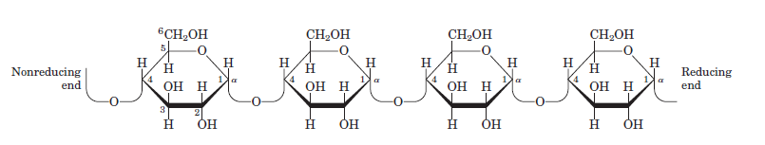

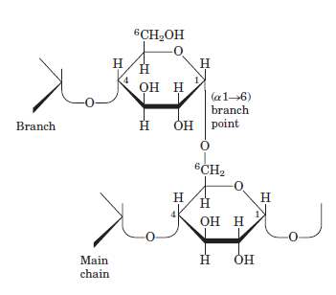
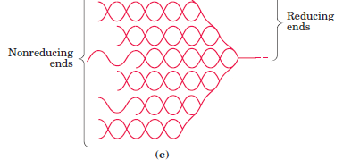
Glycogen structure

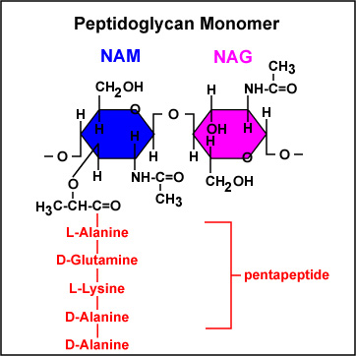

Structure of peptidoglycan
The rigid component of bacterial cell walls is a heteropolymer of alternating (β1-4)-linked N-acetylglucosamine
and N-acetylmuramic acid residues. The linear polymers lie side by side in the cell wall, crosslinked by short peptides, the exact structure of which depends on the bacterial species. The peptide cross-links weld the polysaccharide chains into a strong sheath that envelops the entire cell and prevents cellular swelling
and lysis due to the osmotic entry of water. The enzyme lysozyme kills bacteria by hydrolyzing the (β1-4) glycosidic bond between N-acetylglucosamine and Nacetylmuramic acid. Lysozyme is notably present in tears, presumably as a defense against bacterial infections of the eye. It is also produced by certain bacterial viruses to ensure their release from the host bacterial cell, an essential step of the viral infection cycle. Penicillin and related antibiotics kill bacteria by preventing synthesis of the cross-links, leaving the cell wall too weak to resist osmotic lysis.

